DOCKER COMPOSE – STEP-BY-STEP GUIDE
1. Introduction
Docker Compose is a tool used to create, configure, and run applications that use one or more Docker containers. It uses a YAML file, usually named compose.yaml, to define the application services and their configuration.
2. Step 1: Check Docker Installation
Open the terminal and execute:
docker --version
Explanation: Checks whether Docker is installed.
3. Step 2: Check Docker Compose Installation
docker compose version
Explanation: Displays the installed Docker Compose version.
4. Step 3: Create a Project Directory
mkdir docker-compose-demo
Navigate into the directory:
cd docker-compose-demo
Explanation: Creates a new directory to store the Docker Compose configuration file.
5. Step 4: Create the Compose File
nano compose.yaml
Paste the following configuration:
services:
web:
image: nginx:alpine
ports:
- "8080:80"
Save the file by pressing Ctrl + O, then Enter, and finally Ctrl + X.
Explanation:
- services: Defines the application services.
- web: The name of the service.
- image: nginx:alpine: Uses the lightweight Nginx web server image.
- ports: "8080:80": Maps port 8080 on the host to port 80 inside the container.
6. Step 5: Validate the Compose File
docker compose config
Explanation: Checks the Compose configuration for syntax and configuration errors.
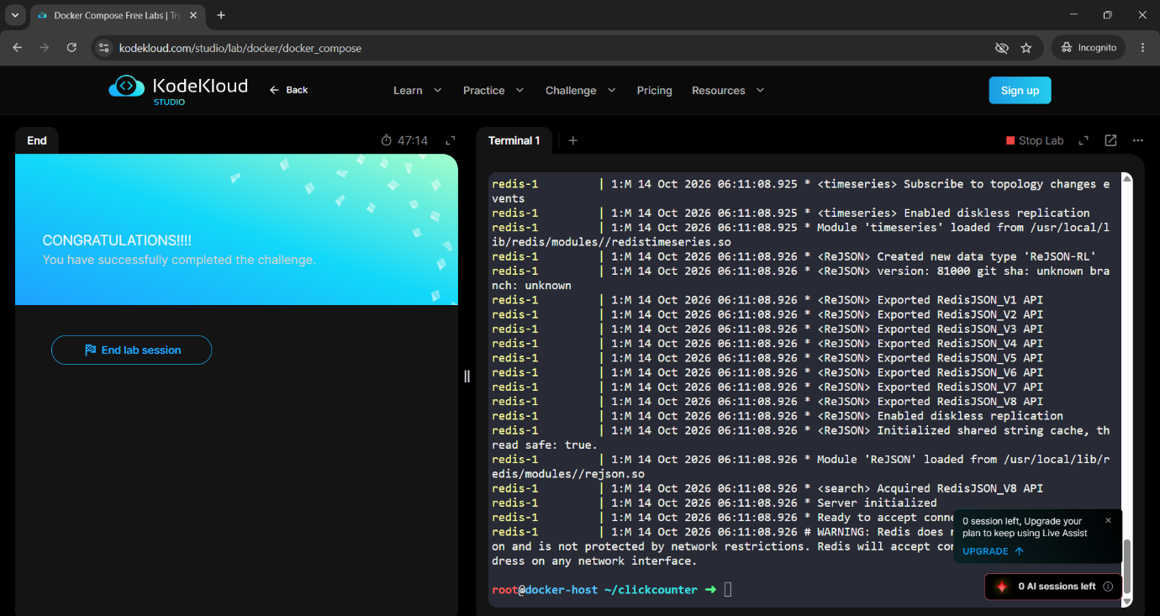
7. Step 6: Start the Container
docker compose up -d
Explanation: Downloads the Nginx image if needed and starts the container in the background.
8. Step 7: Check the Running Container
docker compose ps
You can also execute:
docker ps
Explanation: Displays the running containers and their status.
9. Step 8: Check Docker Images
docker images
Explanation: Displays the Docker images downloaded to the system.
10. Step 9: Access the Application
Open a web browser and enter:
http://localhost:8080
Explanation: If running on your own computer, this should display the default Nginx welcome page. If running in
